**Exp:2**

**30/01/2025**

**Different Visualization Techniques**

**Aim:**

The goal of this experiment is to understand the different visualization techniques using time series data set.

**1. Importing Required Libraries**

import numpy as np

import pandas as pd

import matplotlib.pyplot as plt

import seaborn as sns

**Explanation:**

We import numpy (np) is used for numerical operations, pandas (pd) for data manipulation,

matplotlib.pyplot (plt) for plotting, and seaborn (sns) for statistical data visualization.

**2. Loading the Dataset**

df=pd.read_csv(“/content/cleanedweather.csv”)

**Explanation:**

We use pd.read_csv() to load a CSV file containing Gold data.

**3.Using Scatter plot**

plt.scatter(dataset["USD (AM)"],dataset["GBP (AM)"])

plt.colorbar()

plt.show()

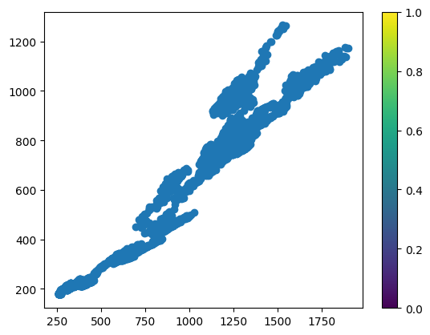

**4.Using Bar plot**

plt.bar(dataset["USD (AM)"],dataset["GBP (AM)"])

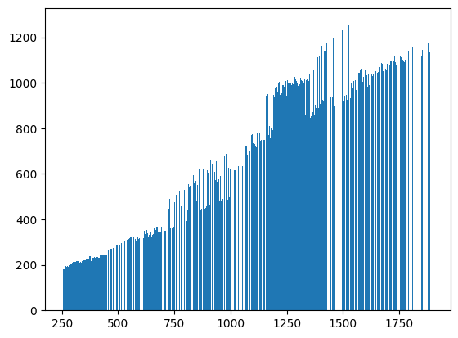

**5.Using Histogram**

plt.hist(dataset["USD (AM)"])

plt.hist(dataset["GBP (AM)"])

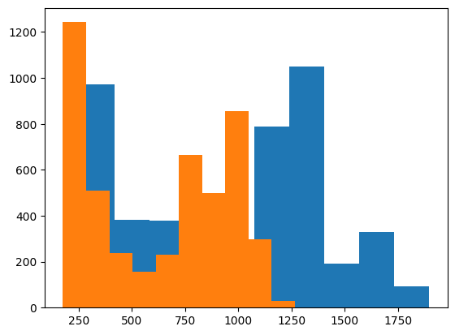

**6.Using Seaborn**

import seaborn as sns

sns.lineplot(x="USD (AM)",y="GBP (AM)",data=dataset)

plt.title("using seaborn visualization")

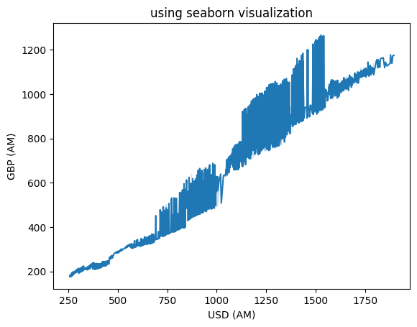

**7.Using Barblot in seaborn**

sns.barplot(x="USD (AM)",y="GBP (AM)",data=dataset)

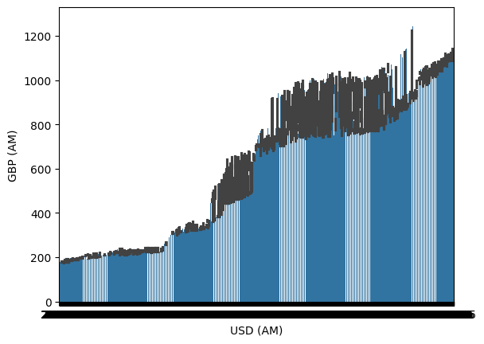

**8.Histplot using seaborn**

sns.histplot(x="USD (AM)",y="GBP (AM)",data=dataset,kde=True)

